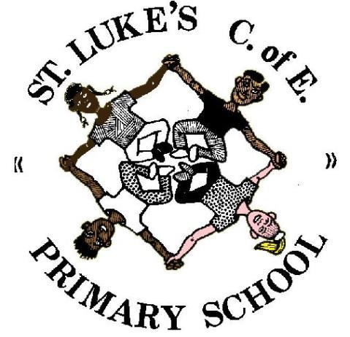
St Luke’s C.E. Primary School

MFL Policy

Langport Avenue
Longsight
Manchester
M12 4NG
MODERN FOREIGN LANGUAGES Policy

Introduction
As part of a new primary National Curriculum, taking effect from September 2014, learning of an MFL has become a requirement for children within KS2. St Luke’s has taught Spanish informally for several years, through after-school clubs, displays around school and activities within classes.

Mr Mitchell (t.mitchell@st-lukes.manchester.sch.uk) is responsible for MFL within St Luke’s.

Aims
We aim to develop children’s experience of language acquisition and encourage curiosity about languages. To develop their understanding of what they hear and read, and have an ability to express themselves in speech and writing. Extend their knowledge of how language works and explore differences between Spanish and English. And strengthen their sense of identity and their understanding of Modern British Values through learning about culture in Spanish speaking countries and comparing it with their own culture.

Teaching and Learning Overview
Teaching is in line with the recommendations of the National Curriculum, with modifications in place which allow for the individual and differentiated needs of the children. It takes full account of the different experiences, strengths and interests of the children whilst also complying with the requirements and guidance on inclusion

The national curriculum for languages aims to ensure that all pupils:
- understand and respond to spoken and written language from a variety of authentic sources
- speak with increasing confidence, fluency and spontaneity, finding ways of communicating what they want to say, including through discussion and asking questions, and continually improving the accuracy of their pronunciation and intonation
- can write at varying length, for different purposes and audiences, using the variety of grammatical structures that they have learnt
- discover and develop an appreciation of a range of writing in the language studied.

Organisation
Spanish is taught in a whole-class setting, by the class teacher or language specialist. Teachers plan using the LCP Spanish Curriculum and have access to resources via Twinkl and the school's library.

The lessons are designed to motivate children from the first moment and are mainly practical in focus. They have clear, achievable objectives and incorporate different learning styles. SEN children have access to the curriculum through variation of task, grouping or support from an adult.

Each KS2 class has a timetabled lesson of at least one hour per week. Spanish can also be revisited in short sessions throughout the week to consolidate knowledge and ensure new language is retained. Spanish lessons provide a variety of sources to model the language, use games and songs to maximise enjoyment and make as many connections to real life situations as possible. Lessons focus on speaking and listening. However, when appropriate, children record written work informally in books and become a portfolio of their learning.

Spanish classes are organised to encourage peer-to-peer learning and as such groups are not ‘set’. Opportunities for catch up exist during assemblies and whole class SODA and reading activities.

Below is an outline of the coverage within KS2
Year 3 | YEAR 4 | YEAR 5 | YEAR 6
Meet and greet | Revision of Year 3 | Countries (flags) | Numbers 1 – 100
Name | Numbers 1 – 31 | Weather | Time
Days | Months | Food and drink | Parts of the body
Numbers 1 – 12 | Birthdays | Celebrations | Clothes adj. agreement
Age | Family | Class objects | Rooms
Colours | Gender (masc./fem.) | Dictionary skills | Dictionary skills
Alphabet | Pets | High frequency phrases | High frequency phrases

Resources
Twinkl
LCP files
Selection of Spanish texts and worksheets

Assessment and record keeping
Progress will be monitored informally and added to the Whole School tracker. Parents are informed of pupil progress via twice yearly Parents Evnings and an end of year report.

Monitoring and evaluation
The MFL Subject leader monitors planning and delivery on a termly basis. Findings are shared with the SLT and the MFL SEF is updated as appropriate.

Progression of skills

Listening
Year 3 | Year 4 | Year 5 | Year 6
Repeat words modelled by teacher, show understanding with an action Children can understand and respond to a few familiar spoken words and short phrases, spoken slowly and clearly. | Listen attentively to spoken language and show understanding by joining in and responding (e.g. with an action) Pick out known words in an ‘authentic’ conversation Children can understand and respond to a range of familiar spoken words and short phrases | Begin to show understanding of more complex sentences in ‘authentic’ conversation, picking out specific vocabulary Children can understand the main points of a short spoken passage made up of a few familiar words and phrases, delivered slowly and clearly. | Listen to and show understanding of more complex sentences in ‘authentic’ conversation, picking out specific vocabulary Children can understand a short passage made up of familiar words and basic phrases.

Speaking

Learn specific vocabulary; develop accuracy in pronunciation by listening to and repeating recordings of authentic speakers Recognise a familiar question and respond with a simple rehearsed response Can repeat and say familiar words and short simple phrases, using understandable pronunciation. | Use common phrases Develop accuracy when pronouncing phrases, by listening to and repeating recordings of authentic speakers Children can and perform short role plays on one topic, with several exchanges and secure pronunciation. Children can produce short pre-prepared phrases on a familiar topic,with secure pronunciation. | Children can ask and answer questions on the current topic. Can produce some short phrases independently (without written support) within a familiar topic, with good pronunciation. on a few very familiar topics. | Engage in short scripted conversations Speaking in longer sentences, learning to use particular sentence structures more flexibly to create your own sentence Children can ask and answer simple questions.

Writing

Copy simple vocabulary Children can write some single words from memory, with plausible spelling. | Children can write simple words and several short phrases from memory. Children use understandable spelling. | Begin to use dictionaries to find the meaning of unknown words and to translate own ideas | Adapt taught phrases to create new sentences

Reading

Begin to recognise written vocabulary/ single words | Begin to recognise written vocabulary/ phrases | Read and show understanding of more complex written phrases | Children can understand a short text made up of short sentences with familiar language on a familiar topic.

Document Control
Title | MFL Policy
Date | April 23
Review | Annually

