Music opportunities in Manchester for our children

Be Hear Now – Children and young people with SEND at The Bridgewater Hall
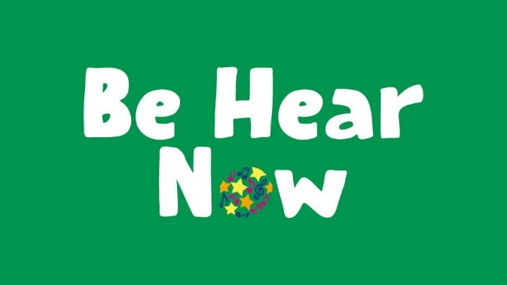
Relaxed musical discovery sessions for children and young people with special education needs and disabilities and their families.
Free tea & coffee is provided for accompanying adults and water for the children and young people.
The Bridgewater Hall, Lower Mosley Street, Manchester. M2 3WS 0161 907 9000

Stoller Story Sounds – The Chocolate Wolf

Saturday 15th July 2023 Stoller Hall at Chetham’s www.stollerhall.com

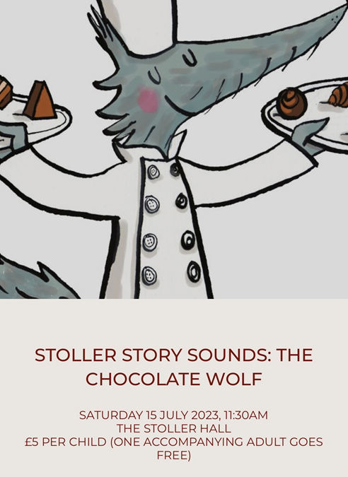
An interactive musical workshop for younger children and their grown-ups.

Manchester Classical

24th and 25th June 2023 Manchester city centre
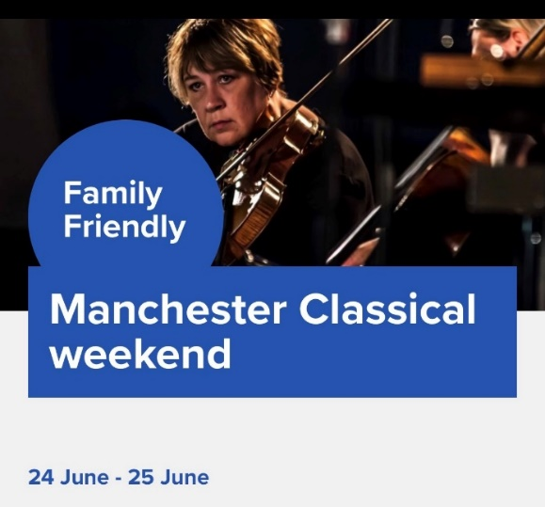
‘Manchester Classical’ is a weekend of performances from the Halle and BBC Philharmonic. Free craft activities and local food and drink are also available. Tickets start at £2 for under-16s with many free performances – all in the heart of the city.

Turn It Up – The Power of Music

Until 21st May 2023 Science and Industry Museum www.scienceandindustrymuseum.org.uk/whats-on/turn-it-up
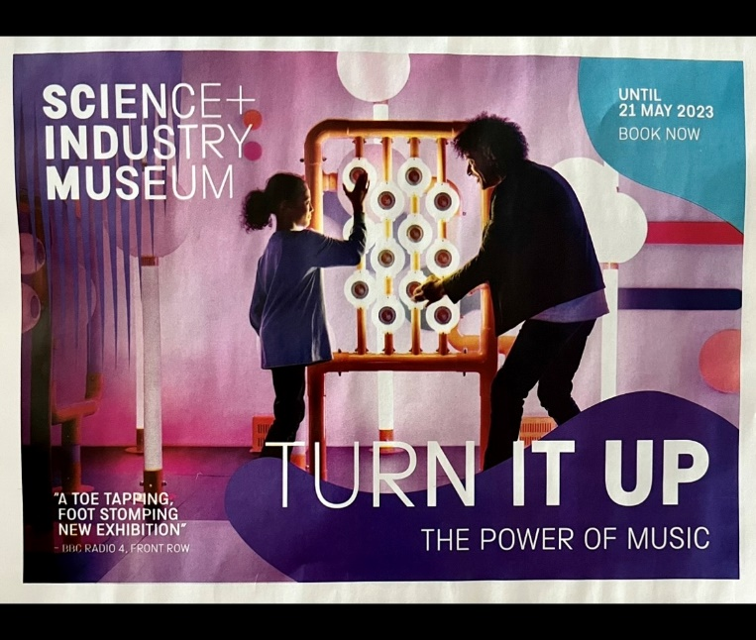
A new exhibition exploring the science of music and how it drives us to create, perform and share. Make music together and play with beat, melody and harmonies in a newly commissioned musical playground!

Stoller Story Sounds – Little Green Dragon

Saturday 20th May 2023 Stoller Hall at Chetham’s www.stollerhall.com
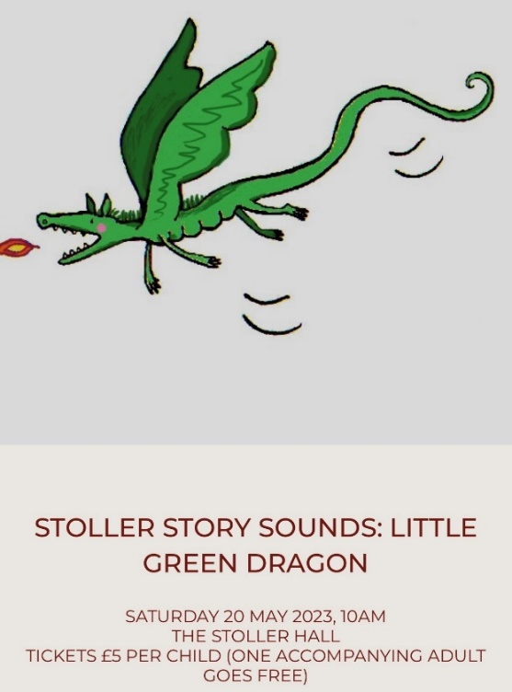
An interactive musical workshop for younger children and their grown-ups.

SpringFest 2023
Saturday 15th April 2023 11am – 4pm Victoria Baths, Ardwick
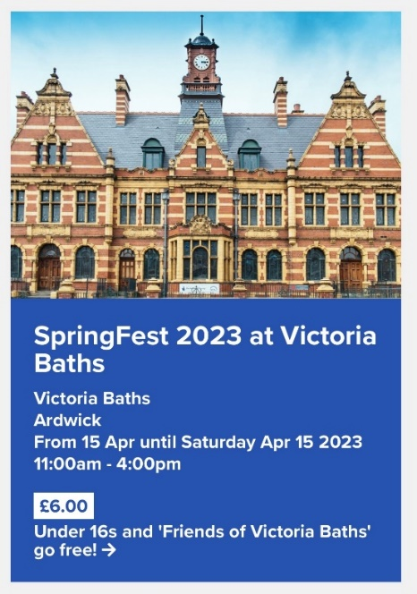
A festival to celebrate music, artists and performers from across Greater Manchester, including live music, art exhibitions, creative activities and refreshments. Under-16s go free!

Xaverian College Easter Concert

Sunday 2 April 2023, 7.30pm RNCM Concert Hall
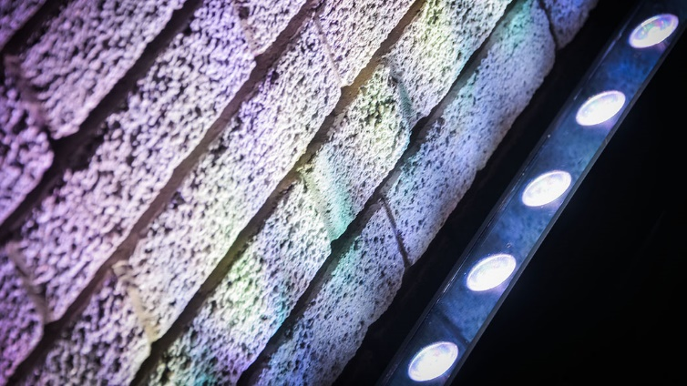
An evening of music from the students at Xaverian College Manchester.

‘Out of This World’ Cheadle Hulme School Spring Concert

Monday 27 March 2023, 7.30pm RNCM Concert Hall

www.rncm.ac.uk/performance/out-of-this-world-cheadle-hulme-school-spring-concert/
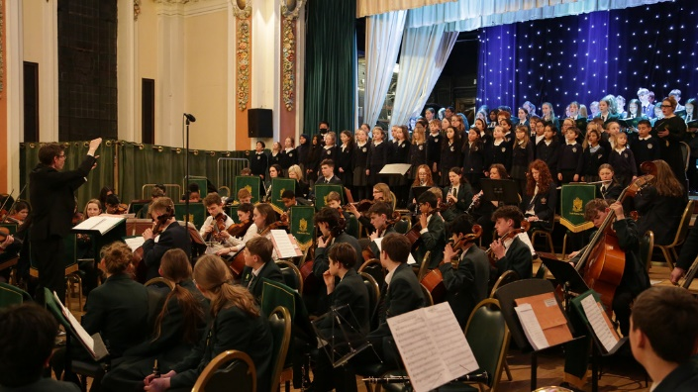
Pupils of Cheadle Hulme School return to the RNCM for their Spring Concert. The concert titled ‘Out of This World’ will see all choirs and ensembles perform music inspired by space, super heroes and fantasy!

